Automated EC2 Instance Management using AWS Lambda and Boto3
Name: Deepak Kumar
Course: Devops & Multi Cloud Batch 15
Date: 28th March 2026

Objective
To automate the starting and stopping of Amazon EC2 instances based on tags using AWS Lambda and Boto3.

Tools & Technologies Used
• AWS EC2
• AWS Lambda
• IAM (Identity and Access Management)
• Python (Boto3 SDK)

Implementation Steps

1. EC2 Instance Setup
Two EC2 instances were created and tagged as follows:
• Instance 1 → Action: Auto-Stop
• Instance 2 → Action: Auto-Start
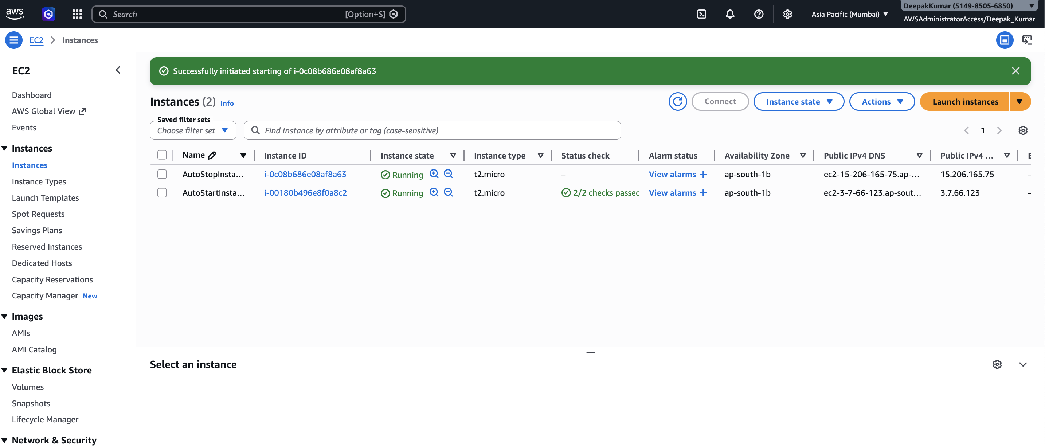

2. IAM Role Creation
An IAM role was created for Lambda with AmazonEC2FullAccess policy to allow EC2 operations.

3. Lambda Function Creation
A Lambda function was created using Python runtime and assigned the IAM role.
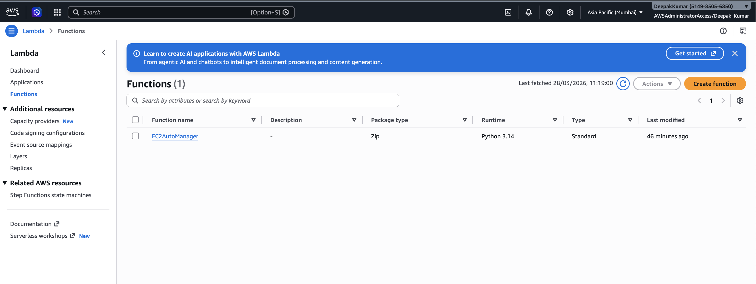

4. Lambda Function Code
import boto3
def lambda_handler(event, context):
ec2 = boto3.client('ec2')
# Stop instances
stop_instances = ec2.describe_instances(
Filters=[
{'Name': 'tag:Action', 'Values': ['Auto-Stop']},
{'Name': 'instance-state-name', 'Values': ['running']}
]
)
stop_ids = []
for r in stop_instances['Reservations']:
for i in r['Instances']:
stop_ids.append(i['InstanceId'])
if stop_ids:
ec2.stop_instances(InstanceIds=stop_ids)
# Start instances
start_instances = ec2.describe_instances(
Filters=[
{'Name': 'tag:Action', 'Values': ['Auto-Start']},
{'Name': 'instance-state-name', 'Values': ['stopped']}
]
)
start_ids = []
for r in start_instances['Reservations']:
for i in r['Instances']:
start_ids.append(i['InstanceId'])
if start_ids:
ec2.start_instances(InstanceIds=start_ids)

5. Testing and Results
The Lambda function was tested manually. Instances were successfully started and stopped based on tags.
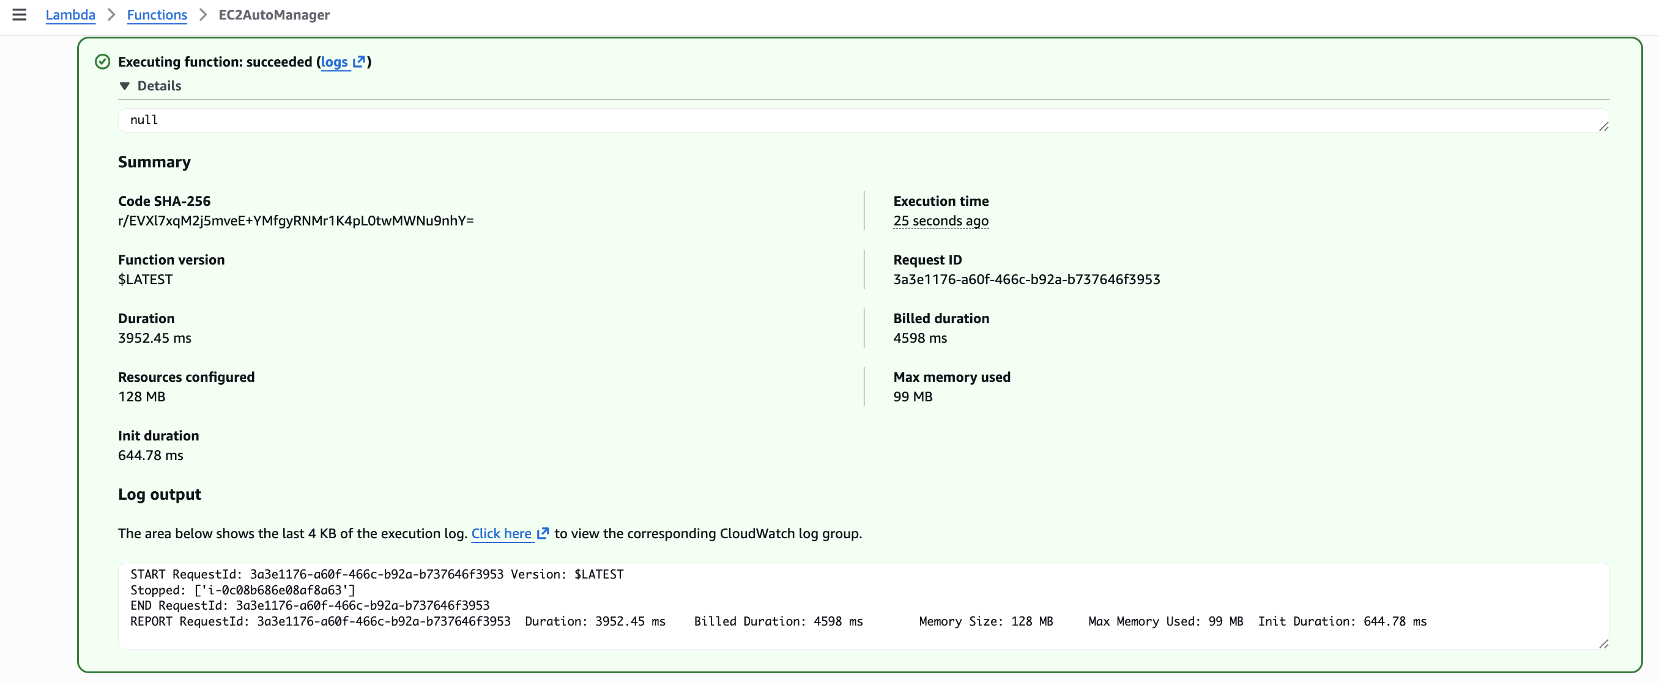

Screenshot After Execution
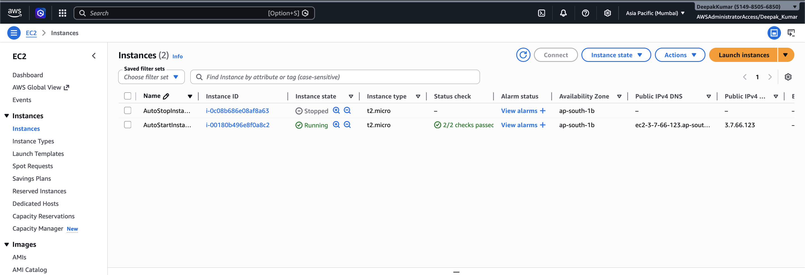

Conclusion
The assignment successfully demonstrated how AWS Lambda and Boto3 can be used to automate EC2 instance management. This helps in reducing manual effort and optimizing cloud costs.

